Event 2002.04.19 – (2002-109)

Particle event: To(Ep>10 MeV) – 19d05^{h}
Tmax₁(Ep>10 MeV) – 19d09^{h}, Jmax₁(Ep>10 MeV) – 1 /cm².s.sr
Tmax₂(Ep>10 MeV) – 19d19^{h}, Jmax₂(Ep>10 MeV) – 2.7 /cm².s.sr
Duration of the event – 2 days
Energy of the SCR and 0.1 GCR fluxes balance – Eb(max₁) = 45 MeV
– Eb(max₂) = 50 MeV
Sources: ◊ Flare activity АR9906
O solar flare 19d15^{h}16^{m}, C2.5/SF, S16W59, АR9906;
Main X-ray burst 1-8 Ǻ: onset – 19d15^{h}16^{m}, max – 19d15^{h}21^{m};
▲ SC 19d08^{h}36^{m};

Particle fluxes and associated phenomena
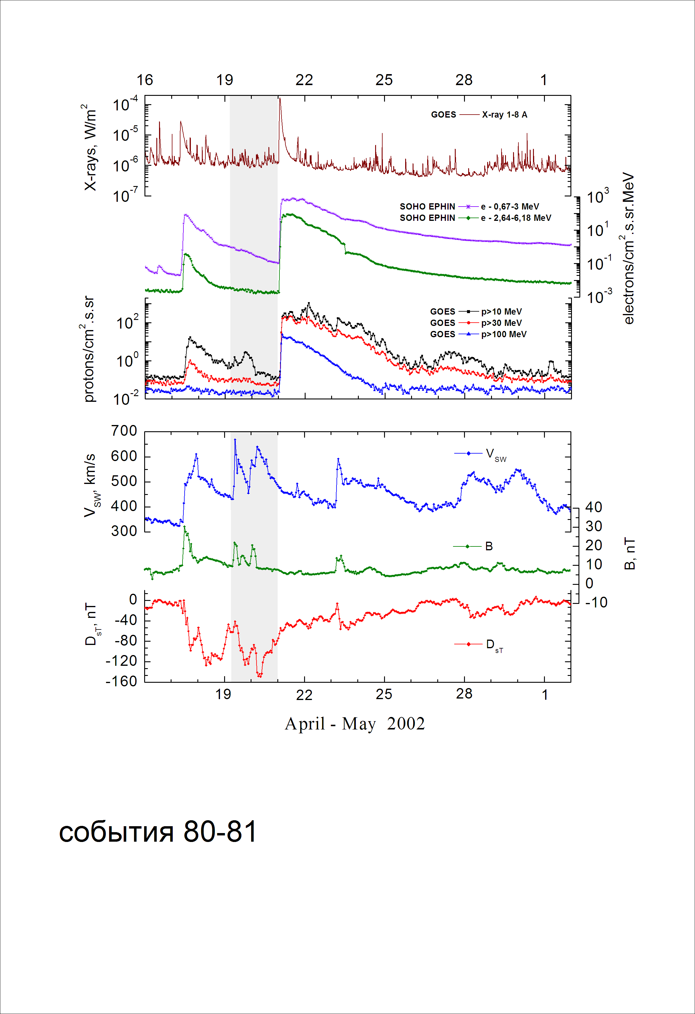

Integral time-of-maximum proton spectrum
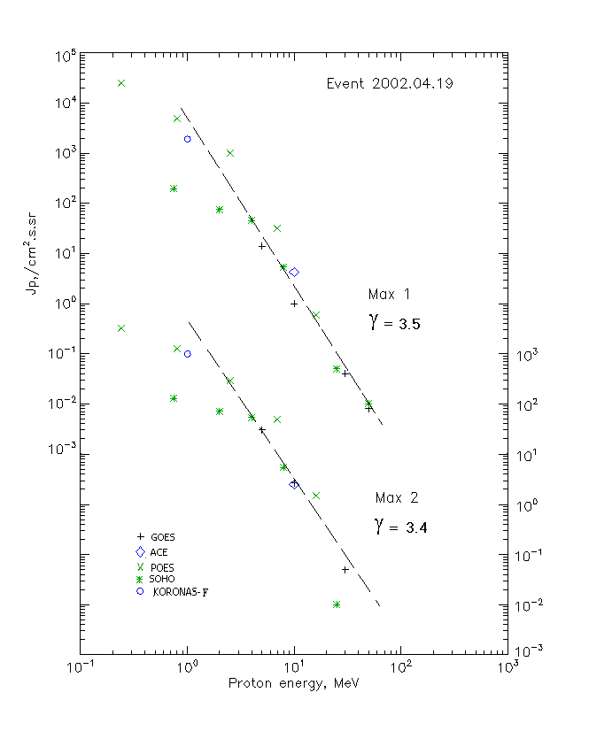

Integral fluxes of protons for the event of 2002.04.19

S/c, instruments | Eр, MeV | To | Tmax | Jmax,  (cm².s.sr)⁻¹ | Dura-tion | Comments
GOES-10
EPS | >5 | 05^{h} | 09^{h}/19^{h} | 14/31 | 2d
EPS | >10 | 05^{h} | 09^{h}/19^{h} | 1/2.7 | 2d
EPS | >30 | 05^{h} | 10^{h}/19^{h} | 0.04/0.05 | 2d
EPS | >50 | 05^{h} | 11^{h}/19^{h} | 0.01/ - | 2d
EPS | >60 | - | - | - | -
EPS | >100 | - | - | - | -
POES-16
MEPED | >0.24 | - | 10^{h}/19^{h} | 25070/3330 | 2d
MEPED | >0.8 | - | 10^{h}/19^{h} | 5040/1340 | 2d
MEPED | >2.5 | - | 10^{h}/19^{h} | 960/320 | 2d
MEPED | >6.9 | - | 10^{h}/19^{h} | 31.5/50 | 2d
MEPED | >16 | - | 10^{h}/19^{h} | 0.6/1.5 | 2d
MEPED | >36 | - | - | - | -
MEPED | >70 | - | - | - | -
MEPED | >140 | - | - | - | -
CORONAS F
MKL | >1. | - | 08^{h}/19^{h} | 1960/930 | 2d
MKL | >14 | - | - | - | -
MKL | >26 | - | - | - | -
MKL | >50 | - | - | - | -
ACE
SIS | >10 | 05^{h} | 08^{h}/19^{h} | 4.2/2.5 | 2d
SIS | >30 | - | - | - | -
SOHO
EPHIN (INT) | >50 | 05^{h} | 08^{h}/ - | 0.01/ - | -

Differential fluxes of protons for the event of 2002.04.19

S/c,  instruments | ∆Е, MeV | To | Tmax | Jmax, (cm².s.sr.MeV)⁻¹ | Dura-tion | Comments
SOHO
LION | 0.75-2 | 05^{h} | 08^{h}/20^{h} | 97/46 | 2d
LION | 2-6 | 05^{h} | 08^{h}/20^{h} | 10/5.8 | 2d
EPHIN | 4-8 | 05^{h} | 09^{h}/19^{h} | 10.1/12.3 | 2d
EPHIN | 8-25 | 05^{h} | 09^{h}/19^{h} | 0.31/0.32 | 2d
EPHIN | 25-41 | 05^{h} | 08^{h}/18^{h} | 0.0015/0.0003 | 2d
EPHIN | 41-53 | - “ - | - “ - | - “ - | - “ -

References:
No information on publications, excepting for:
http://www.swpc.noaa.gov/ftpdir/indices/SPE.txt

