Event 2003.11.02 – (2003-306) – GLE-67

Particle event: To(Ep>10 MeV) – 02d17^{h}
Tmax(Ep>10 MeV) – 02d23^{h}, Jmax (Ep>10 MeV) – 990 /cm².s.sr
Duration of the event – 2 days
Energy of the SCR and 0.1 GCR fluxes balance – Eb = 1700 MeV

Sources: ● solar flare 02d17^{h}03^{m}, X8.3/2B, S14W56, АR10486
Ø solar flare 01d22^{h}26^{m}, M3.2/1N, S12W60, АR10486 - contribution of event
Ø solar flare 03d01^{h}06^{m}, 2B/X2.3, N10W83, АR10488 beginning
Main X-ray burst 1-8 Ǻ: onset – 02d17^{h}03^{m}, max – 02d17^{h}25^{m}, Ф = 0.91 J/m²
CME: 02d17^{h}30^{m}, V = 2598 km/s; ∆φ = 360º; dA = 265º
▲SC: 04d06^{h}25^{m}

Particle fluxes and associated phenomena
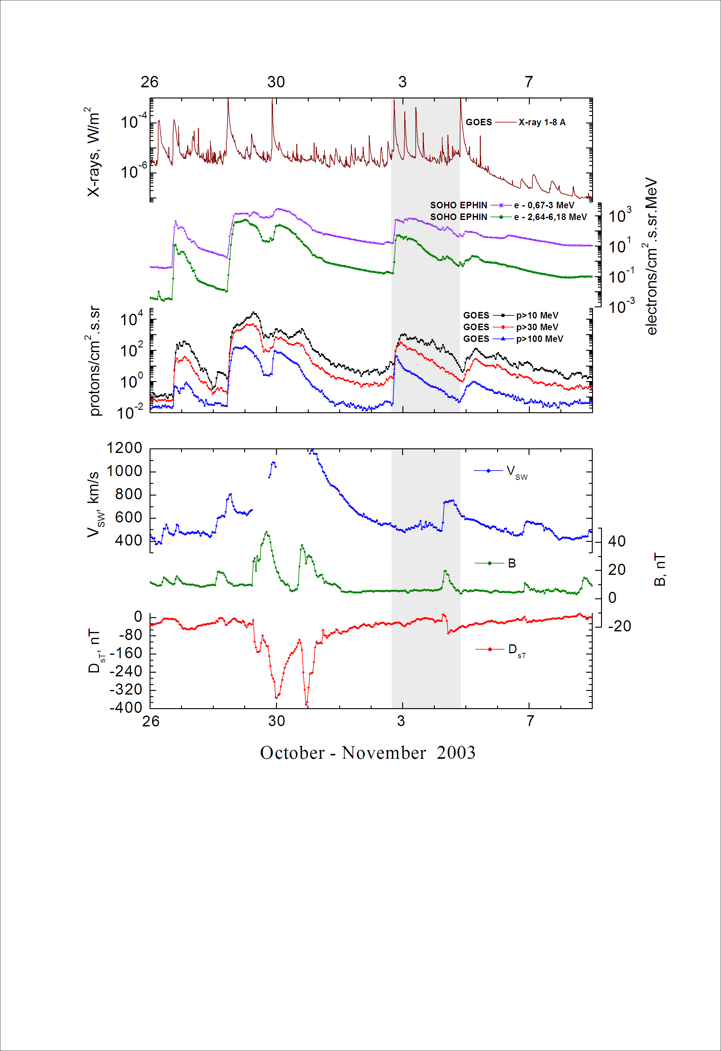
Integral time-of-maximum proton spectrum
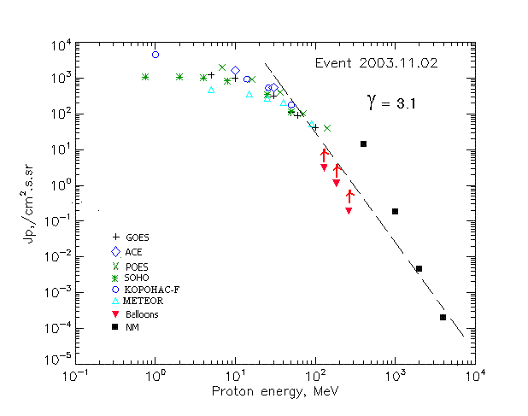

Integral fluxes of protons for the event of 2003.11.02

S/c, instruments | Eр, MeV | To | Tmax | Jmax,  (cm².s.sr)⁻¹ | Dura-tion | Comments
GOES-10
EPS | >5 | 17^{h} | 23^{h} | 1220 | 2d
EPS | >10 | 17^{h} | 23^{h} | 990 | 2d
EPS | >30 | 17^{h} | 22^{h} | 320 | 2d
EPS | >50 | 17^{h} | 20^{h} | 110 | 2d
EPS | >60 | 17^{h} | 19^{h} | 89.5 | 2d
EPS | >100 | 17^{h} | 19^{h} | 42 | 2d
METEOR
CBM | >5 | 17^{h} | 21^{h} | 470 | 2d
CBM | >10 | 17^{h} | 21^{h} | 355 | 2d
CBM | >25 | 17^{h} | 19^{h} | 270 | 2d
CBM | >40 | 17^{h} | 19^{h} | 214 | 2d
BP | >90 | 17^{h} | 19^{h} | 53 | 2d
ChD | >600
POES-16
MEPED | >0.24 | ⁻ | - | - | ⁻
MEPED | >0.8 | ⁻ | - | - | ⁻
MEPED | >2.5 | ⁻ | - | - | ⁻
MEPED | >6.9 | ⁻ | 21^{h} | 2070 | 2d
MEPED | >16 | ⁻ | 19^{h} | 930 | 2d
MEPED | >36 | ⁻ | 19^{h} | 420 | 2d
MEPED | >70 | ⁻ | 18^{h} | 110 | 2d
MEPED | >140 | ⁻ | 18^{h} | 40 | 2d
CORONAS F
MKL | >1. | ⁻ | 19^{h} | 4520 | 2d
MKL | >14 | ⁻ | 19^{h} | 940 | 2d
MKL | >26 | ⁻ | 19^{h} | 540 | 2d
MKL | >50 | ⁻ | 19^{h} | 180 | 2d
ACE
SIS | >10 | 17^{h} | 23^{h} | 1630 | 2d
SIS | >30 | 17^{h} | 20^{h} | 540 | 2d
SOHO
EPHIN (INT) | >50 | 17^{h} | 19^{h} | 117 | 2d
BALLOONS
Mu | >129 | - | 03d(00^{h}56^{m}÷01^{h}32^{m}) | 3 | - | After
Mu | >184 | - | 03d(00^{h}56^{m}÷01^{h}32^{m}) | 1.13 | - | maximum
Mu | >263 | - | 03d(00^{h}56^{m}÷01^{h}32^{m}) | 0.19 | -
NM
Network | >433 | - | 18^{h} | 15.5 | -
Network | >1000 | - | 18^{h} | 0.183 | -
Network | >2000 | - | 18^{h} | 0.00465 | -
Network | >3700 | - | 18^{h} | 0.00018 | -

Differential fluxes of protons for the event of 2003.11.02

S/c,  instruments | ∆Е, MeV | To | Tmax | Jmax, (cm².s.sr.MeV)⁻¹ | Dura-tion | Comments
SOHO
LION | 0.75-2 | 14^{h} | 23^{h} | 18.6 | 2.5d
LION | 2-6 | 13^{h} | 23^{h} | 12.4 | 2.5d
EPHIN | 4-8 | 12^{h} | 22^{h} | 47 | 2.5d
EPHIN | 8-25 | 12^{h} | 22^{h} | 28.7 | 2.5d
EPHIN | 25-41 | 18^{h} | 22^{h} | 8.2 | 2d
EPHIN | 41-53 | - “ - | - “ - | - “ - | - “ -

References:
Kuwabara T., J.W. Bieber, J. Clem, et.al., 2006.
Kuznetsov S.N., Yushkov B.Yu., and Kudela K., 2007.
Miroshnichenko L.I. and Perez-Peraza J., 2008.
Веселовский И.С., Мягкова И.Н., Яковчук О.С., 2012.
Maurchev E.A., Balabin Yu.V., Vashenyuk E.V., et.al., 2013.

