Event 1998.04.30 – (1998-120)

Particle event: To(Ep>10 MeV) – 30d02^{h}
Tmax₁(Ep>10 MeV) – 30d15^{h}, Jmax (Ep>10 MeV) – 1.3 /cm².s.sr
Tmax₂(Ep>10 MeV) – 01d15^{h}, Jmax (Ep>10 MeV) – 1.2 /cm².s.sr *)
Duration of the event – 2 days
Energy of the SCR and 0.1 GCR fluxes balance – Eb(max₁₎ = 65 MeV
– Eb(max₂₎ = 75 MeV
*) Data from IMP-8 (CPME)

Sources: ● solar flare 29d16^{h}00^{m}, M6.8/3B, S16E22, АR8210
Main burst X-ray 1-8 Ǻ: onset – 29d16^{h}00^{m}, max – 29d16^{h}37^{m}, Ф = 0.1 J/m²
CME: 30d16^{h}58^{m}, V = 1374 km/s, Δφ = 360º, dA = 336 º
ΔSC 01d21^{h}56 ^{m}

Particle fluxes and associated phenomena
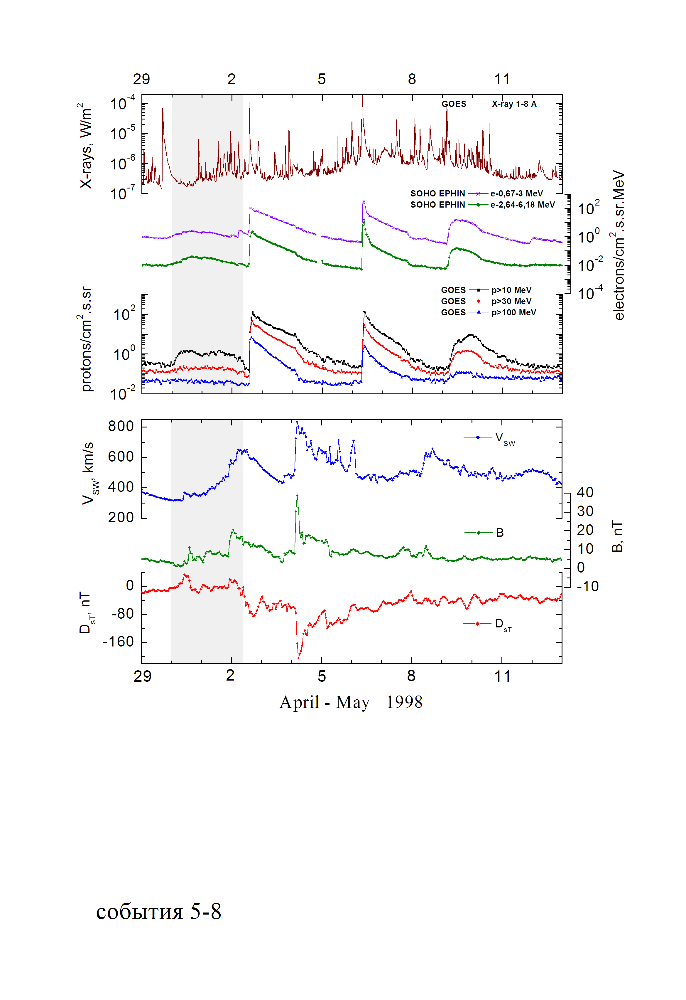
Integral time-of-maximum proton spectrum
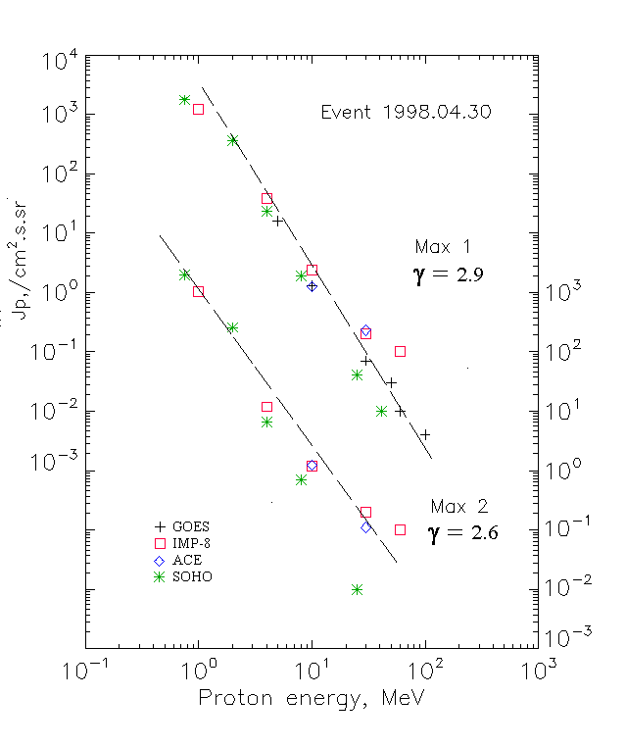

Integral fluxes of protons for the event of 1998 April 30

S/c, instruments | Eр, MeV | To | Tmax | Jmax,  /cm2.s.sr | Dura-tion | Comments
GOES-9
EPS | >5 | 01^{h} | 15^{h}/ - | 16/ - | >2d
EPS | >10 | 01^{h} | 15^{h}/ - | 1.3/ - | >2d
EPS | >30 | - | 15^{h}/ - | 0.07/ - | -
EPS | >50 | - | 15^{h}/ - | 0.03/ - | -
EPS | >60 | - | 15^{h}/ - | 0.01/ - | -
EPS | >100 | - | 15^{h}/ - | 0.004/ - | -
IMP-8
CPME | >1 | 01^{h} | 15^{h}/01d21^{h} | 1210/1050 | 2.5d
CPME | >4 | 01^{h} | 15^{h}/01d19^{h} | 38/11.9 | 2.5d
CPME | >10 | 01^{h} | 15^{h}/01d15^{h} | 2.4/1.2 | 2.5d
CPME | >30 | 01^{h} | 17^{h}/01d09^{h} | 0.2/0.2 | 2.5d
CPME | >60 | 01^{h} | 17^{h}/01d12^{h} | 0.1/0.1 | 2.5d
ACE
SIS | >10 | 01^{h} | 16^{h}/01d12^{h} | 1.24/1.25 | 2.5d
SIS | >30 | 01^{h} | 16^{h}/01d13^{h} | 0.23/0.11 | 2.5d
SOHO
EPHIN (INT) | >50 | - | - | - | -

Differential fluxes of protons for the event of 1998 April 30

S/c, instruments | ∆Е, MeV | To | Tmax | Jmax. /cm².s.sr.MeV | Dura-tion | Comments
IMP-8
CPME | 1-2 | 00^{h} | 15^{h}/01d21^{h} | 930/1040 | 2.5d
CPME | 2-4.6 | 01^{h} | 15^{h}/01d21^{h} | 112/480 | 2.5d
CPME | 4.6-15 | 01^{h} | 15^{h}/01d19^{h} | 2,4/0,6 | 2.5d
CPME | 15-25 | 01^{h} | 17^{h}/01d08^{h} | 0,03/0,05 | 2.5d
CPME | 25-48 | - | - | - | -
CPME | 48-96 | - | - | - | -
CPME | 96-145 | - | - | - | -
CPME | 145-440 | - | - | - | -
SOHO
LION | 0.75-2 | 01^{h} | 15^{h}/01d21^{h} | 1110/1360 | 2.5d
LION | 2-6 | 01^{h} | 15^{h}/01d21^{h} | 83/63 | 2.5d
EPHIN | 4-8 | 01^{h} | 14^{h}/01d18^{h} | 5.3/1.5 | 2.5d
EPHIN | 8-25 | 01^{h} | 14^{h}/01d15^{h} | 0.11/0.04 | 2.5d
EPHIN | 25-41 | 01^{h} | 14^{h}/01d12^{h} | 0.002/0.0005 | 2.5d
EPHIN | 41-53 | - “ - | - “ - | - “ - | - “ -

References
No information on publications, excepting for:
http://www.swpc.noaa.gov/ftpdir/indices/SPE.txt

