Event 1998.08.22 – (1998-234)

Particle event: To(Ep>10 MeV) – 22d06^{h}
Tmax₁(Ep>10 MeV) – 23d00^{h}, Jmax₁(Ep>10 MeV) – 1.7 /cm².s.sr
Tmax₂(Ep>10 MeV) – 23d08^{h}, Jmax₁(Ep>10 MeV) – 1.5 /cm².s.sr
Duration of the event – 2 days
Energy of the SCR and 0.1 GCR fluxes balance – Eb(max₁) = 80 MeV
– Eb(max2) = 85 MeV
Sources: ● solar flare 21d23^{h}57^{m}, M9.0/2B, N42E51, АR8307
Main burst X-ray 1-8 Ǻ: onset – 21d23^{h}57^{m}, max – 22d00^{h}09^{m}, Ф = 0.061 J/m²
CME: gap

Particle fluxes and associated phenomena
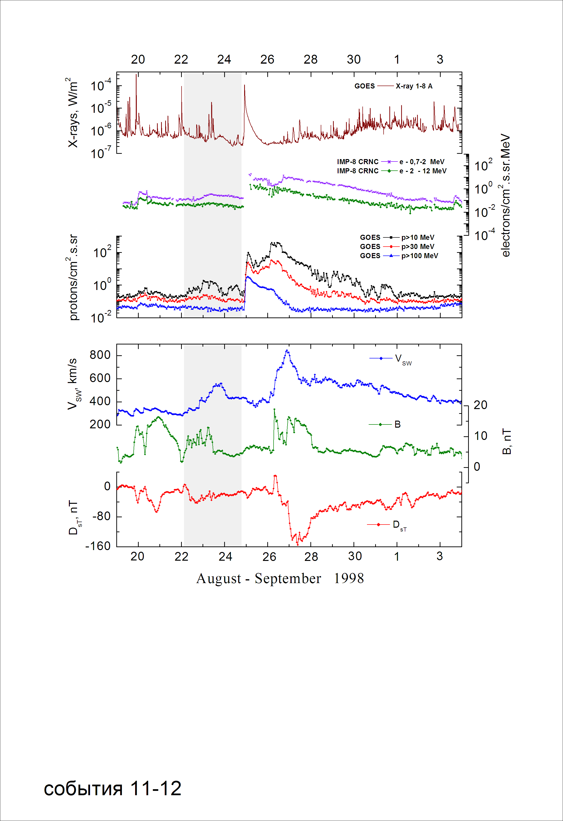
Integral time-of-maximum proton spectrum
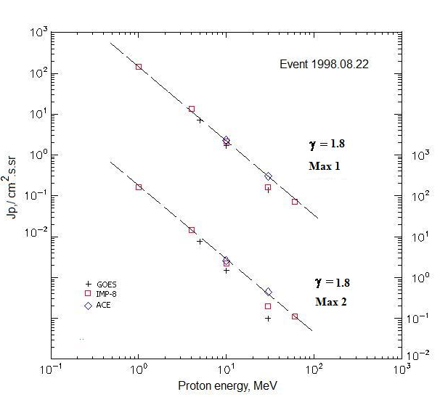

Integral fluxes of protons for the event of 1998 August 22

S/c, instruments | Eр, MeV | To | Tmax | Jmax,  /cm².s.sr | Dura-tion | Comments
GOES-10
EPS | >5 | 06^{h} | 23d00^{h}/23d08^{h} | 7/7.6 | 2d
EPS | >10 | 06^{h} | 23d00^{h}/23d08^{h} | 1.7/1.5 | 2d
EPS | >30 | 06^{h} | 23d00^{h}/23d09^{h} | 0.14/0.1 | 1d
EPS | >50 | - | - | - | -
EPS | >60 | - | - | - | -
EPS | >100 | - | - | - | -
IMP-8
CPME | >1 | 06^{h} | 23d00^{h}/23d08^{h} | 146/165 | 3d
CPME | >4 | 06^{h} | 23d00^{h}/23d08^{h} | 13.6/14.4 | 3d
CPME | >10 | 06^{h} | 23d00^{h}/23d08^{h} | 2.15/2.25 | 3d
CPME | >30 | 06^{h} | 23d00^{h}/23d08^{h} | 0.16/0.2 | 2d
CPME | >60 | 06^{h} | 23d00^{h}/23d08^{h} | 0.07/0.11 | 2d
ACE
SIS | >10 | 06^{h} | 23d00^{h}/23d08^{h} | 2.3/2.6 | 2d
SIS | >30 | 06^{h} | 23d01^{h}/23d08^{h} | 0.3/0.45 | 2d

Differential fluxes of protons for the event of 1998 August 22

S/c, instruments | ∆Е, MeV | To | Tmax | Jmax. /cm².s.sr.MeV | Dura-tion | Comments
IMP-8
CPME | 1-2 | - | - /23d08^{h} | - /110 | -
CPME | 2-4.6 | - | - /23d08^{h} | - /18.5 | -
CPME | 4.6-15 | - | - /23d07^{h} | - /0.9 | -
CPME | 15-25 | - | - /23d07^{h} | - /0.06 | -
CPME | 25-48 | - | - | - | -
CPME | 48-96 | - | - | - | -
CPME | 96-145 | - | - | - | -
CPME | 145-440 | - | - | - | -
SOHO |  | Data | absent

References
No information on publications, excepting for:
http://www.swpc.noaa.gov/ftpdir/indices/SPE.txt

