Solar proton anisotropy and dropout effects in the polar cap and auroral zone during period of the extended substorm activity
Kuznetsov S.N., and Lazutin L.L.

Institute of Nuclear Physics, Moscow State University, Vorob'evy gory, Moscow, 119899 Russia

Abstract. Measurements of the latitude distribution of solar protons by Coronas-F polar orbiter during solar proton events allows to study dynamics of the proton penetration boundary. Polar cap and penetration boundary relative position were investigated due to the South-North anisotropy registered during SCR event on October 26-27, 2003. Dropout effects of the proton radial distribution were found suggesting specific field line stretching inside the magneosphere trapping region during period of extended substorm activity.

INTRODUCTION

Solar cosmic rays (SCR) of the lower edge of the energy spectra, 1-100 MeV, penetrate without restriction into the Earth's magnetotail and auroral zone down to the L=2.5 during strong magnetic storms [Perejaslova, 1982]. When solar proton flux in the interplanetary space is anisotropic, similar south-north anisotropy may be observed in the polar cap. That allows to estimate boundary of the taillike and closed magnetic field lines.
In the auroral zone solar protons are quasitraped, which means that their motion although non-adiabatic, have three regular components, Larmor gyration, bounce oscillation between the mirror points and magnetic drift. In some cases particles can afford several drift rotations, then proton intensities in auroral region are higher than in interplanetary space.
During extended period of the substorm activity on October 26-27, 2003, CORONASA-F satellite particle detectors registered unusual effect of intensity dropouts on some restricted regions of the auroral zone. In present paper we investigate this phenomena and propose possible explanation.
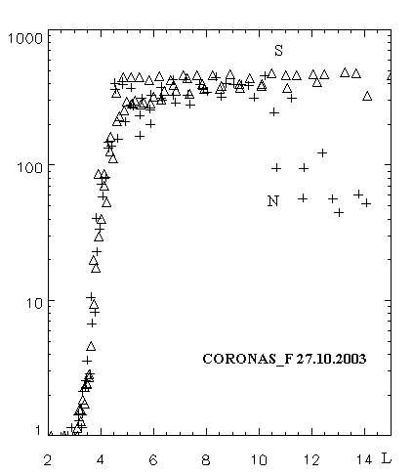
Fig 1. Radial profiles of the 1-5 MeV protons
across the North and South hemispheres

OBSERVATIONS AND DISCUSSION

CORONAS-F satellite was launched on polar orbit at the altitude 500 km. Proton detector data used in our study has four differential energy channels from 1 to 100 MeV. Solar cosmic ray evens was detected on October 26, 2003, about 18 UT and during several hours strong North-South anisotropy was detected.

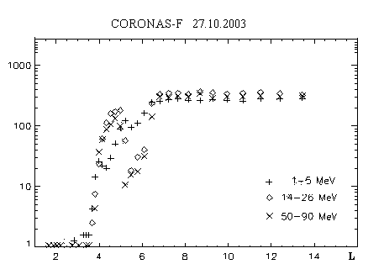
Figure 1 shows 1-5 MeV proton measurements in both polar caps versus L. North cap intensity was almost one order smaller than the South one on L>11 while closer to the Earth intensities became equal. That indicates penetration of the protons to the close field line region as deep as L=4 or even L=3 (background penetration boundary). Such deep penetration from the magnetotail can be imagined if the boundary of open field lines in a magnetosphere itself will be moved deep enough earthward. With the polar cap boundary at L=11 one must allow direct proton penetration to the closed field lines through the flanks of the magnetosphere (inner LLBL) [ Panasyuk et al., 2004].
Fig. 2. Solar proton redial profiles with intensity dropout

Along with the radial profiles with the flat plato over the polar cap as shown by fig 1., there were recorded radial profiles with deep counting rate dropouts in auroral zone (Fig 2.). Two main features of the dropouts can be outlines. First, amplitude of the dropout depends on the energy: effect on the 1 -5 MeV channel usually is significantly smaller than in 50 -90 MeV one. The second feature is a essential variability of the amplitude and latitude width of the effect. This variability is not random, but depends on the intensity and phase of the substorm activity. Figure 3 shows an H-component of the magnetometer at Lovozero observatory, which was at the nightside during the period under discussion. One can see, that satellite passes with large effect were located near the time of magnetic bay maxima, while during bay recovery or small activity intervals dropout effect was small or absent.

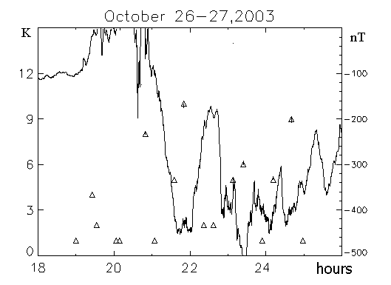
Fig. 3. Relative depth of the 50 MeV proton dropouts (K) and H-component of the Lovazero magnetogram.

DISCUSSION AND CONCLUSION

Solar protons with energy 1-100 MeV during magnetic drift does not follow precise equal B trajectory, they can change drift envelopes due to the radial diffusion. But the rate of the earthward and outward diffusion is nearly equal and radial profiles are usually smooth. Opposite situation may occurs if some magnetic field lines are taillike stretched as shown at Fig 4.

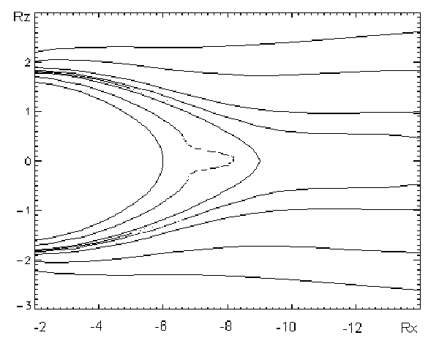

Fig 4. Possible magnetic field configuration during solar proton dropout events

Radial diffusion flux from such field lines will be greater than flux toward its from more dipollike field lines, both on smaller or greater radial distances. The difference will be energy dependent, as the Larmor radius versus magnetic field line ratio will increase with increase of the energy. Direct measurements and modeling of the localized magnetic field line distortion during substorms [ Kozelov and Kozelova, 2004] suggest that such distortion as shown by fig 4. may exist.
If this simple interpretation of the dropout effect is true, that opens possibility to reconstruct instant magnetic field configuration during the auroral substorm activity.

ACKNOVLEGMENTS

Authors are grateful to A.G. Jahnin for magnetometer data.
This work was partially supported by RFBR grant # 06-05-64225

REFERENCES

B.V.Kozelov, T.V. Kozelova, Dynamics of domains of
nonadiabatic particle motion in the inner magnetosphere during substorm,
Geomagnetism and Aeronomy, V. 43, No.4, pp. 448-497, 2003
Panasyuk M.I., Kuznetsov S.N., L.L. Lazutin et al., Magnetic storm in October 2003, Collaboration "Solar Extreme Events in 2003 (SEE-2003"), Cosmic Research, 42, #5, 489-534, 2004
Perejaslova N.K. Solar protons in the Earth's magnetosphere, in: Energetic particles in the Earth's magnetosphere, Acad. Sci. USSR, Apatity, p. 3- 25, 1982

