CREATION AND DESTRUCTION OF THE SOLAR PROTON BELTS IN THE INNER MAGNETOSPHERE DURING MAGNETIC STORMS.

Lazutin L.L., Kuznetsov S.N., and Podorolsky A.N.,

Moscow State University,
Scobeltsyn Institute for Nuclear Physics,

Space Physics Division
Vorob'evy Gory, Moscow
119992, Russia

Abstract

Along with the stable inner proton belt, temporal variations of the 1-15 MeV protons at L=2.5-3.5 have been reported, with intensity increases and decreases registered during and after strong magnetic storms. As a source of this additional proton population, energetic plasmasheet ions and solar protons were considered. For the explanation of the origin of the additional proton belt the models of resonant acceleration and radial particle injection were introduced, with strong electric field induced by the compression of the magnetosphere as a driver.
Our study presents experimental evidences that creation and destruction of solar proton belts in the inner magnetosphere may be produced by the fast shifts of the proton penetration boundary without additional acceleration and injection. Our conclusions are based on the solar protons and ions measurements by low altitude polar orbiter Coronas-F during October - November 2003 magnetic storms events. Several times creation and destruction of solar cosmic ray belts were observed during this interval. Compression of the magnetosphere make possible direct penetration of the solar protons deep into the magnetosphere. Inside the proton penetration boundary particle trajectories are open and previously trapped particles are free to escape. During magnetosphere reconfiguration when penetration boundary shifts away from the Earth, solar protons and alpha particles with relatively low magnetic drift velocity became stable trapped. Therefore discussed effect differs from the SC induced solar proton injection events by the restricted energy range of the trapped protons.

keywords: 2720 Energetic particles, trapped, 2740 Magnetospheric configuration and dynamics, 2788 Storms and substorms

1. INTRODUCTION

Proton radiation belt with energy from 0.1 to 100 MeV located at L=1.3-5 was studied well during the first decades of the satellite era. Solar wind 1-10 keV protons and 50-100 keV magnetospheric (auroral zone) protons are accepted as a source of proton belt population for this energy. Radial transport brings protons from the boundary to the inner magnetosphere with betatron acceleration (Parker, 1960, Tverskoy, 1965, Falthammar, 1965). For the protons with energy >40 MeV, albedo neutrons produced by galactic cosmic rays are regarded as an additional source. The proton radiation belt is rather stable, essential variations caused by magnetic activity were observed regularly only near the outer proton belt boundary.
Nevertheless, observations of the proton intensity variations of short time scale during magnetic storms became accumulated. Bostrem et al., (1970) observed both increases and decreases of the proton intensity on L=2-4 at low-energy range (1-15 MeV). Existence of the additional proton maximum on L=2-4 was reported in several publications. Slocum et al. (2002) found 11 events when new radiation belts appeared during magnetic storms and solar cosmic ray events from 2000 to 2002. One of the belts appeared on November 24, 2001 they observed at least until July 2002.

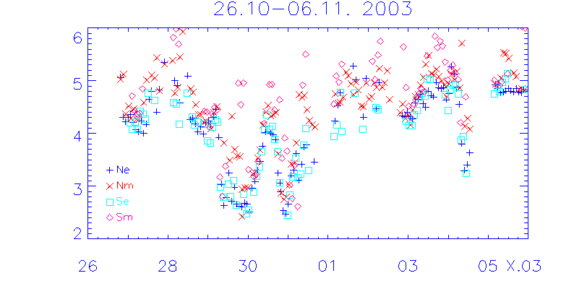
Fig. 1 Solar 1-MeV protons penetration boundary position.

Lorensen et al., (2002) found additional trapping regions of 2-15 MeV protons during strong magnetic storms of 1998 и 2000. Solar origin of this particles follows from the presence of the helium ions.
Considerable progress in understanding of this phenomena was achieved when
several minutes after the sudden commencement (SC) of the March 24, 1991 magnetic storm, enhanced energetic ions and electrons were registered by CRRES satellite in the inner magnetosphere (Blake et al., 1992). It was suggested that particles might be resonantly accelerated and injected inward by the E-field pulse induced by impulsive compression of the magnetosphere during SC (Li et al., 1993, Pavlov et al., 1993, Hudson et al., 1997). Although similar direct measurements were not repeated during other magnetic storms, the SC injection model became popular.
There are certain restrictions on the energy range of the particles which may be accelerated during SC by the resonant mechanism. If trapped particles have not sufficient energy and their magnetic drift is slow as compared with the duration of the SC impulse, they will not leave dayside region after acceleration and will be returned to the previous radial distance and adiabatically decelerated. Therefore arrival of the additional 1 MeV proton flux at L=2.5-3.5 after magnetic storms needs alternative model for the explanation.

During the strong magnetic storms the boundary of 1-100 MeV solar cosmic ray (SCR) penetration (cutoff latitude) moves to the inner magnetosphere. Deep penetration of the the SCR may enable the direct trapping of solar protons without additional acceleration. Present paper shows that one or several solar proton belts can be created and/or destroyed during magnetic storms due to the fast reconfiguration of the Earth's magnetosphere.
The paper is based on the measurements of the energetic protons and ions by particle spectrometers on board of the polar low-altitude satellite Coronas-F during October-November 2003 magnetic storms.

2. MEASUREMENTS

Coronas-F particle detector MKL has four proton differential channels (1-5, 14-26, 26-50 and 50-90 MeV); mainly we will use MKL data in our study. In addition data of two proton and two alpha particle channels (2.3-4.2 and 4.2-19 MeV/nuclon) of the mass-spectrometer SKI were inspected and will be presented if necessary. At the altitude of 500

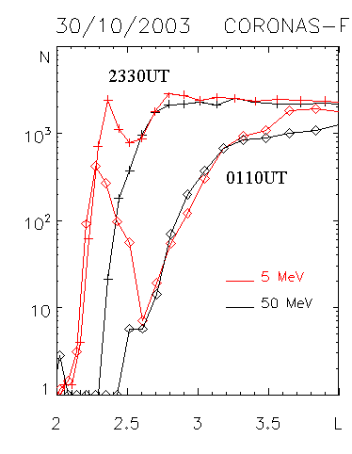 | 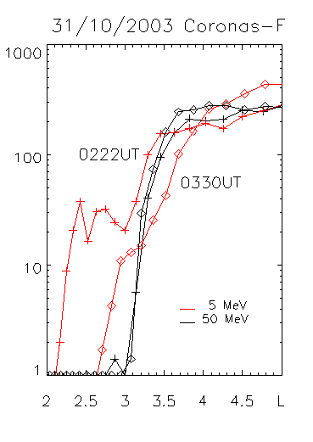

Fig 2 (left) Measurements of the double PB dynamics by Coronas-F spectrometer, 30/10/03, two consequent crossings in the evening sector of the South hemisphere. PB of 50 MeV protons are shown by black lines, and 1-5 MeV ones by red color. Intensity in the 50 MeV channel was normalized to the 1-5 MeV flux in polar cap.
Fig 3 (right) Two more examples of the double boundary during morning flights in the South (02.22 UT) and North (03.55 UT) hemisphere.

km trapped particles may be seen only over the Brazilian Magnetic anomaly (BMA), and adjacent South-Atlantic region, while on the majority of the trajectories only precipitating particles were recorded.
Detailed discussion of the solar events and extreme magnetic storms on October 2003 have been published in two cooperative papers (Veselovsky et al., 2004 and Panasyuk et al., 2004), which allow us to omit general magnetic storm description.
The flux of the SCR was high and variable and penetrates deep inside the inner magnetosphere.
Fig 1 shows temporal variations of the solar proton penetration boundary (PB) during the last October and the first November days of 2003. PB position was taken in our case at the 0.01 value of 1-5 Mev proton polar cap level. Solar protons have direct access to the radial distances where additional proton fluxes were reported in previous studies.
For the problems of solar proton belts formation it is important to outline the impulsive character of the PB motion, both toward and away from the Earth. It is reasonable to suppose that if the PB retreat time is smaller than particle magnetic drift period, such particles will remain trapped on the closed orbits. Such conclusion follows from the observation results presented bellow.

2.1 Double penetration boundary of solar 1-5 MeV protons.

The closest to the Earth position of the solar proton boundary (PB), L= 2.0-2.2 was recorded at 2220UT October 30 during the satellite flight in the evening sector of the South hemisphere. From this moment PB
started to move back, which was possible to trace from the measurements by three high energy channels (14-90 MeV). At the same

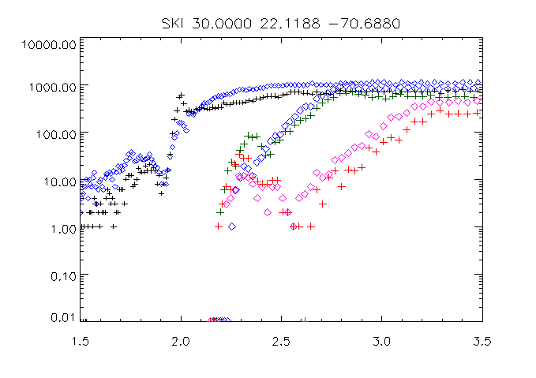
Fig 4. Double boundary event measured by SCI detector.

time low energy protons have double-boundary structure.
Figure 2 shows two PB crossings in the south-evening sector at 2330UT and 0110 UT, October 31. Intensities along the PB of the 50-90 MeV are shown by black lines and the PB of 1-5 MeV channel by red lines. Counting rates of both energy channels are normalized to coincide with 1-5 MeV intensity in the polar cap. One can see that 1-5 MeV channel has double boundary structure: during the first part of the satellite flight toward high latitudes intensity increase follows old, closer to the Earth boundary, then after interval of the decrease, counting rate again begin to grow along the new boundary, which coincides with the boundary of energetic protons.
Similar double boundary was observed in other sectors, both during the flight toward the lower latitudes and back, therefore it was not a result of some temporal variations. Fig.3 shows morning sector flights at 02-04UT October 31, near the end of the interval of double boundary phenomena. The intensity of the inner boundary is small, but double boundary structure is still fairly evident.
As a reasonable explanation of this effect we consider that part of the 1-5 MeV protons remained trapped during fast retreat of the penetration boundary. Their drift trajectories which were open in a quasitrapping region became closed, thus creating new solar proton belt.
During analyzed measurements inner magnetosphere was populated by large fluxes of energetic particles, protons and electrons, but we are sure that registered data by 1-5 MeV MKL proton channel were not affected by detectors imperfection. Strong support of the reliability of double boundary effect gave measurements by SKI, different by detectors compilation and geometry.

Figure 4 shows double boundary recorded by SKI. Effect was present in 2.2-4.2 and 4.2-19 MeV proton channels and absent in alpha particle channels. During the first PB crossing at 2206UT the nearest to the Earth PB position was recorded. Closer to the Earth at L=1.5-1.9 a stable "normal" proton belt can be seen. The next two flights in the same sector reveal double boundary structure. While the outer boundary moved away from the Earth, the inner boundaries remain at the same place for both channels.
The relative intensity of 4.2 MeV proton flux is one order smaller than 2.2 MeV, therefore the energy limit of the particles trapped in the solar proton belt is higher than but close to 4 MeV.

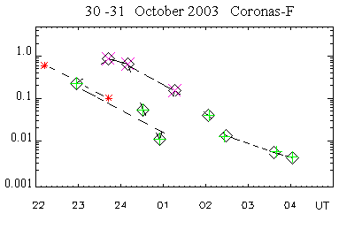
Fig. 5. Decrease of the precipitating 1-5 MeV proton flux from the inner boundary region. Crosses and squares belong to the evening and morning flights while stars presents SCI data.

The intensity of the protons at the inner boundary decreased rapidly. Let us remember that only precipitating particles are recorded. Fig 5 presents the diagram of the intensity decrease at the maximum of the inner boundary. The intensity in the polar cap is taken as a unity. Red signs belong to the evening sector, other to the morning one. The solid lines link measurements in the same sectors. Two points (stars) belong to the 2.2-

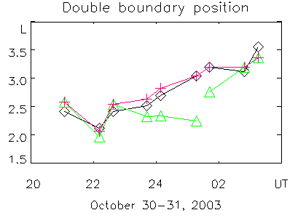
Fig. 6. Penetration boundary motion during double-boundary event. Diamonds and crosses belong to 1-5 and 50-90 MeV outer boundary measured at the intensity level of 0.5 from the polar cap level. Shifted crosses are positions of the inner boundary.

4.2 MeV SKI proton data. Morning sector points shifted upward between 01UT and 02UT which may be explained if we suppose that new boundary retreat creates the new SCR belt.
The rate of the intensity decrease is the same for all measurements and can be described as follows:

N(t) = No exp(-kt)

where t – is a time in hours and k is equal to 1.15.

Fast decrease of the registered proton flux does not mean the decay of the solar proton belt. It only means the disappearance of the proton flux from the loss cone. While magnetic field lines recover dipolar shape, the rate of the pitch angle diffusion on field line curvature decreases sharply and particles remain stable trapped, sometimes for many days as we will see below.
Figure 6 presents the dynamics of the penetration boundaries during the double boundary interval. The position was taken at the level of 1/10 from the intensity maximum. The outer boundaries of all energies from 1-5 to 50-90 МэВ coincide and move away from the Earth (or to the higher latitudes) while the inner boundary of 1-5 MeV for several hours remain stable and slightly moves earthward until 01 UT 31.10.03. After that it shifts from L=2.3 to L=2.8 and soon became undistinguished from the main PB. This shift coincides with the change of the proton flux in the inner boundary (see Fig 5) associated with new SCR belt formation.
Double boundary effect was absent in all three higher MKL energy channels (14-26, 26-50 and 50-90 MeV) and in two SKI channels. The relative intensity of 4.2 MeV proton flux was one order smaller than 2.2 MeV, therefore energy cutoff of the effect was somewhere between 4 and 14 MeV. High energy protons change their drift trajectories in accordance with the reconfiguration of the magnetosphere due to the conservation of the third adiabatic invariant, while low energy protons are drifting slowly comparing with the reconfiguration rate and became trapped into closed orbits.

2.2 Solar proton belts observed over BMA

The trajectory of the Coronas-F at the 500 km altitude most of the flight time went below the radiation belts with the exception of the Brazilian and South Atlantic anomaly. Here we can register the radial profile of the inner radiation belts and study their transformation.

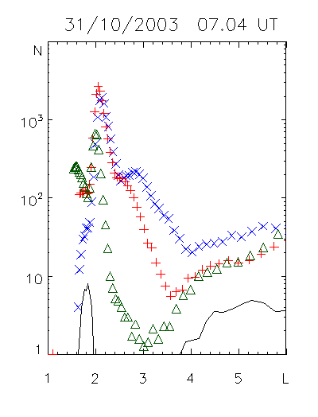

Fig.7. Two solar 1-5 MeV solar proton belts created after the main phase of the 30-31/10/05 extreme storm as seen during several Coronas-F flights over Brazilian and North Atlantic magnetic anomaly in the morning on 31/10/03. Black line shows the 50-90 MeV proton profiles.

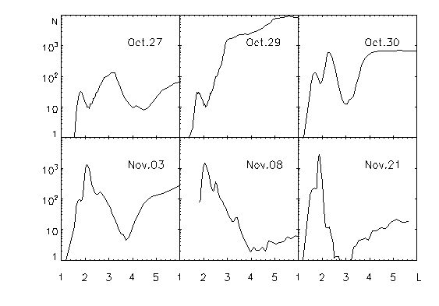

Fig.8. Solar proton belts registered during six Coronas-F flights over North-Atlantic magnetic anomaly from 26/10/03 until 21/11/03

The satellite trajectories came over different part of the magnetic anomaly, and recorded profiles are visibly different from pass to pass. One can see that on Figure 7 which shows 1-5 MeV proton profiles for three consequent flights over BMA at the morning of the October 31, 2003, immediately after the end of the main phase of the last October storm. By the solid line measurements of the 50-90 MeV protons show one stable inner proton belt with maximum at L=1.6. The same maximum can be identified also in 1-5 MeV data, but here two new additional peaks are seen at L=2.1 and L=2.8. Their location coincides with the inner boundary of the double-boundary profiles discussed in previous section and there are no doubts that they are populated by trapped solar cosmic rays.
Some additional MeV proton belts were recorded in all inspected flights over BMA from October 20 to November 25, 2003 but with different intensity and position. Figure 7 present examples of the BMA radial profiles of 1-5 MeV protons. The number of additional peaks at this examples varied from one on October 27 and November 21 to three on November 8. There were no additional peaks on October 29 pass over BMA immediately after beginning of the first storm and the first compression of the magnetosphere.
We tabulated intensity and position of every intensity maximum for all days from October 22 to November 25 and present resulting plots intensity versus time and intensity versus position (L) by Figure 8 a and b.
Although the position and intensity of the belts maximum are recorded with obvious uncertainty discussed above, it is clearly seen that points are combined into four groups with similar intensity and position. Consequently four solar proton radiation belts can be identified.
Before the extreme storms single solar proton belt was seen at L=3.4 ( Fig 7a and the red stars on Figure 8). This belt disappeared at the morning October 29 when the proton penetration boundary approached the Earth and previously trapped protons found itself free to escape from the quasitrapping region.
During the disturbed interval from October 29 to 31 when one storm came after another and penetration boundary move several times toward the Earth and back, several temporal

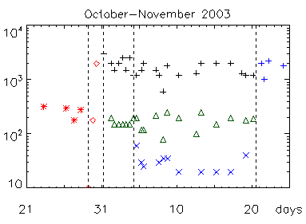
Fig.9a SCR belts maximum intensity versus time, vertical broken lines indicate start of the superstorm at 29.10 and the end of the main phase at 31/10, the end of 04.11 magnetic storm and the beginning of the 20/11/03 superstorm.

solar proton belts were created and destroyed (Fig 7c).
From the figures 8 one can see that points between October 29 and 31 does not belong to any of four stable groups. That emphasizes short time of their life.
Two solar proton belts seen for the first time in the morning of October 31, were created at the end of the last main storm phase with maximum L=2.1 и L=2.6-2.8 (Fig 6), their formation was recorded as described above by double-boundary effects. There were no magnetospheric disturbances strong enough to destroy these two belts until November 20 magnetic storm. One can see that those two maxima exist without significant change of the amplitude and position (black crosses and green triangles on Fig 8).
The third additional solar proton belt joins previous two after the moderate magnetic storm, which occurs on November 4. The earthward boundary motion was not deep enough (L=3) to destroy the previously created belts, but during reverse boundary motion small but well distinguished proton flux was trapped with the maximum on L=3.4-3.5 (blue crosses on Fig 8). This three solar proton belts structure is shown for November 8 at Fig.7e.
We do not know trapped proton pitch angle distribution, but if is legitimate to extend measured profile to the equatorial region, this unique four-belt structure will have an appearance illustrated by Fig 10.
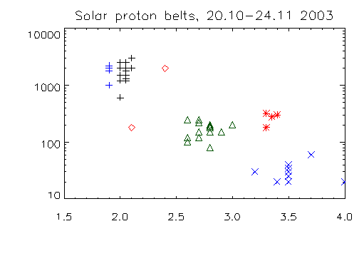
Fig 9b SPS maximum intensity versus position L, the signs are the same as in fig. 8a

Measurements on November 17 were used when SCR intensity decreased essentially and therefore particle flux behind PB was seemly smaller than in two inner SCR belts.
After the magnetic storm of 20.11.03 the radial profile of the trapping region was changed again: two outer solar proton belts disappeared, the inner belt survived but was noticeably shifted earthward from L=2.05 to L=1.9 approaching closer to the main inner radiation belt. There were no solar cosmic rays registered during this storm and therefore additional SCR belts have not been created.

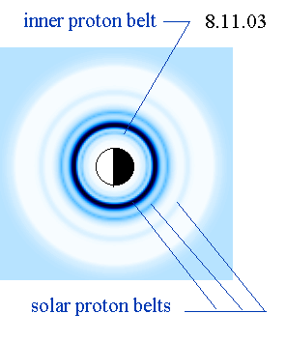
Fig.10. Reconstruction of the main inner proton belt (0) and three solar proton belts (1-3) from the Coronas-F measurements of 17/11/03. (4) - current position penetration boundary.
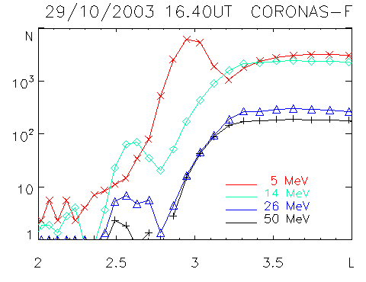
Fig 11a Traces of the energetic protons in transitory SCR belt 29/10/03

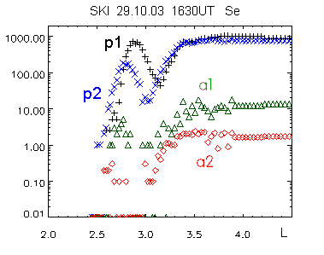
Fig 11b. Protons and alpha-particles in transitory SCR belt 29/10/03

The new profile with one solar proton belt remains detectable during one month but the amplitude of the L=1.9 peak decreased rapidly as shown by Fig 10. Why time history of solar proton belts changed after November 20 storm from stability to fast decay remains unclear.

2.3 On the energy spectrum of the trapped solar protons

During the formation of the double boundary we did not found effect in the high energy proton channels (E>14 MeV) of the MKL spectrometer. In the solar proton belts measured after the morning of October 31 also there were no protons with energy more than 14 MeV. Examination of the SCI measurements over BMA during 29-31
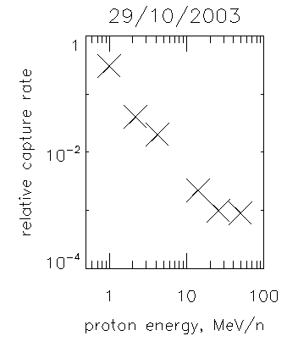
Fig. 12 Dependence of the relative intensity and position of the ions maximum from the energy in transitory SCR belt 29/10/03

magnetic storm session shows that most often trapping effect was recorded only in two low-energy solar proton channels and in one case only in 2.2-4.2 MeV channel alone.
But there was one orbit over BMA on October 29, at 1640 UT, when intensity of the solar cosmic rays was at maximum, which gave the possibility to measure trapping effect in high energy channels. The counting rates in the temporary proton belt registered by 50 -90 MeV channel was only 0.1% of the polar cup intensity, but still well above the background. Figures 11a shows the measurements in four MKL channels and figure 11b presents measurements in two SKI proton and two alpha particle channels.

The effect was present in all proton energy channels.

Relative intensity of the particles in the belt as compared with the polar cap flux decrease with the energy as shown by figure 12. Energy dependence can be approximated by the power low N = No E^{-k} when k = 2 .
In this case one can see that alpha particles were trapped as well. Alpha particle energies per nuclon were plotted, their intensity do fit well with proton distribution. It is not surprising, because particles magnetic drift velocity depend on the energy per nuclon value.

3. DISCUSSION

There are two evident reasons why described solar proton trapping cannot be explained by SC injection model. It is clear, that effectiveness of this mechanism depends on the particle energy. Shifted earthward and accelerated proton must have sufficient drift velocity to be able to drift from dayside to nightside sector before the end of the positive SC impulse. Otherwise it will be adiabatically returned tot the previous radial distance with resulting zero acceleration. Drift period might be estimated by the following empirical relation:

$T=\frac{\text{44}}{\text{LE}}$

where Т in minutes and E – particle energy in MeV.

For the 1-5 MeV protons T = 11- 2.2 minutes at L = 4, which is much more than SC pulse duration (< 10s), therefore SC injection mechanism is not effective for such low energy particles.
Second restriction follows from the estimation of the value of particle radial shift δL durind SC. It can be calculated according to [Pavlov и al ., 1993] as
$$δL=L_{f}−L_{i}=\frac{8}{\text{21}}⋅\frac{h_{\text{max}}}{\text{Ho}}⋅{\left(\frac{L_{f}+L_{i}}{2}\right)}^{5}$$
where L_{i} and L_{f} are initial and final particle radial position, H_{o} and h_{max}– magnitude and maximal deviation of magnetic field at the Earth’s surface. Before the SC PB was located at L=3.7, while maximum of the new 1-5MeV belt after SC during the early morning satellite pass was registered at L=2.4. For such radial shift one need h_{max} = -400 nT, which is 4 times more than registered value. Which also proves that SC injection model is not appropriate for the explanation of the observed effects.

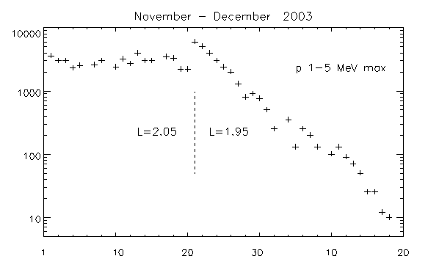
Fig 13 SCR 1-5 MeV belt intensity versus time plot. L=2.05 before and 1.95 after N0vember 20, 2003 magnetic storm.

Alternative explanation of the formation of 1-5 MeV SCR belt during the fast magnetosphere reconfiguration does not encounter significant difficulties. It comprise following sequence of the processes related to the trapping of the solar cosmic rays into the inner magnetosphere starts after the commencement of the magnetic storm:

1. Change of the magnetosphere configuration bring the inner boundary of the quastrapping region (and of the auroral zone) toward the Earth;
2. Radiation belt particles, electrons and ions, behind the PB which were previously trapped, transfer to the open orbits are free to leave the magnetosphere;
3. If solar cosmic rays are present in the near-earth interplanetary space, then the quasitrapping region will be filled by SCR, possibly by the diffusion, possibly through the LLBL;
4. During the step-like recovery of the magnetosphere and associated retreat of the SCR penetration boundary, part of the solar cosmic ray flux will transfer to the closed drift orbits and create new solar cosmic rays belt. It may be wiped out by the following earthward shift of the boundary, or remains stable long after the end of the magnetic storm. There might be two or more such belts after strong structurated magnetic storms.
5. Induced electric field during magnetosphere recovery will shift the inner belts eartward.

Following steps of solar cosmic rays dynamics may be conceived from the analyzed observations based on this model.
29.10, ~ 0630 UT. Penetration boundary approached to L=2.3 and previously existed SPB at L= 3.3 vanished, particle orbits became open and they left the magnetosphere. 29-30.10 Several SPB were created and destroyed due to the PB motion.
30.10, 22-23UT. The innermost SPB was created with the beginning of the magnetic storm recovery phase during the PB retreat from L=2-2.2
31.10, 02-04UT. PB retreat from L=2.5 to L=3.5 created the second SPB. For the first time both SPB were seen by Coronas-F detectors during flights over BMA at the morning of October 31.
04.11.03 ~ 1935UT. Moderate magnetic storm caused earthward PB motion down to L=3.2-3.5 at 1935 UT with following retreat to L=4. As a result new SPB was created with maximum at L=3.5, while two previously created SPB remain unaffected.
20.11.03 Two outer SPB disappeared when PB approached approximately to L=2.5. The inner SPB survived but shifts inward from L=2.05 to L=1.9. Distance from the inner belt decreases to 0.2-0.3 Re. New SPB were not created during this storm because it was not accompanied by the acceleration of the solar cosmic rays.

Trapping of SCR particles during penetration boundary retreat is a central part of this process, therefore is necessary to discuss it in more details. Typical time of the magnetosphere reconstruction equals to several minutes. For example change of the magnetic field registered by GEOS-10 on October 30, 2003, when magnetosphere boundary was passing away from the Earth, took 10 minutes. Magnetic drift period for 1 MeV and 50 MeV protons at L= 3 is about 15 minutes and 20 s accordingly. That means that energetic protons are drifting too fast and leave magnetosphere without respond for magnetosphere reconfiguration. Low energy 1 MeV protons drifts 50 times slower and can remain at the trapping orbits.
The probability for protons (and ions) to became trapped decrease with energy which follows from the model is indeed supported by our observations. The steep energy spectrum of the SCR will additionally influence on the sharp cutoff at 2-10 MeV of the energy population in the solar radiation belts. It is possible, that very fast PB shift may provide trapping of more energetic particles.

From November 4 till November 20 unique inner proton belt structure was observed with one usual stable inner belt and three additional SCR belts as shown by figure 10.
Of cause, it is correct if the trapped protons have normal pitch angle distribution. Actually w do not know real PAD and observed structure might be the same if associated trapped particle increases are restricted to the pitch angles close to the loss cone. Investigation of the real PAD is an important task for the future progress.
During the proton penetration boundary retreat, change of the pitch angle distribution of the particles remaining in the belt must take place. Before that in the quasitrapping region most probably it was isotropic due to the pitch-angle diffusion on the magnetic field lines curvature. After the reconfiguration of the magnetosphere, magnetic field lines became more dipolar, and pitch-angle diffusion decreases rapidly. Precipitating flux decreases tenfold in 1.5 hours.

Slocum et al., [2002] reported that after November 24, 2001 magnetic storm SCR belt remains at least during one year. Our results show that new radiation belt remains without sensible changes until the next strong magnetic storm (more than 20 days). But after November 20 magnetic storm the intensity of 1-5 MeV protons in the SCR belt at L=1.9 gradually decreases and finally less than in one month this belt disappeared ( fig. 11). The problem of the stability of additional inner radiation belts will be studied in a separate paper.

The process of the erosion of the previously existing belts by the PB inward motion might be important not only for MeV protons but for the trapped particles of higher energy. Mentioned by Bostrem et al. [1970] variations of the particle intensity at L=2-4 during magnetic storms, both increases and decreases might be understood by the PB motion model. It is necessary to mention that intensity decrease in the inner belt during October 2003 magnetic storm was recorded by Looper et al., [2004]. They mentioned distortion of the magnetosphere as one of three possible explanation of this decrease, although without discussion and with large question sigh. Authors of this work does not found effects discussed in our paper because they analyzed measurements of the protons with energy > 29 MeV and used large time averaging.

Therefore, along with the old known sources of the inner radiation belts, such as cosmic ray neutron albedo and radial diffusion solar cosmic rays contribution might be considered as well. As an accepted mechanism of this contribution charged particle injection with additional acceleration has been considered. Along with SC injection model, possible injection during magnetic field recovery (dipolarization) have been suggested (Pavlov et al., 1993). What is proposed in our study is a new and rather simple mechanism describing how MeV solar cosmic rays can be directly trapped without additional acceleration. There are no doubts about the SCR origin of these new belt population because we capture the process of the belt formation in action during double penetration boundary interval.

The erosion process may impose certain restrictions for the mechanism of the resonant acceleration and injection during SC discussed in introduction as an important source of the radiation belt. PB motion starts after the SC and can destroy enhanced energetic particle flux accelerated previously either by fast SC-type injection or by slow radial diffusion.
Both processes, creation of SCR belts and erosion of previously existed trapped particles might be important for the space weather radiation models.
As the closest recorded position of the PB was at L=2, the inner belt part at L<2 will be conserved during extreme magnetic storms.

4. CONCLUSIONS

Solar proton trapping into the inner magnetosphere (L=2-4) have been observed previously during several magnetic bays. Accepted explanations were based on resonant particle radial injection during SC. SC-type injection was registered by CRRES satellite particle detectors, receive theoretical explanation and reproduced by computer modeling. This mechanism demand large amplitude of the SC impulse for deep injection into the inner magnetosphere and is restricted for the solar protons with energies >15 MeV. SCR belt created by SC injection might be destroyed during the main phase by inward motion of the SCR penetration boundary as described in present paper.

In a present paper we propose new type of SCR trpping into the inner magnetosphere supported by the analysis of the experimental data. The trapping of solar protons (ions) which penetrate into the inner magnetosphere during the main phase occurs as a result of the transition from the open to the closed drift paths during the recovery of the magnetosphere configuration without additional acceleration and injection. Injection effect was recorded, but it did not play the major role.
Considered mechanism works effectively only if the impulsive recovery of the magnetosphere configuration was rather fast as compared with the particle magnetic drift period. It imply restriction on the energy of the protons and alpha particles. Particles with the energy larger than 5-15 MeV/nuclon might be trapped only in a rare occasions.
Following foundings might be listed:

1. Solar protons with energy 1 MeV and higher after earthward shift of the penetration boundary might be trapped during the boundary retreat, creating solar cosmic ray belt on L= 2 - 4.
2. In some cases 2 or even 3 SCB can be created.
3. In new SCB stable trapping condition became established quickly. The flux of precipitation protons decrease exponentially as N=No exp(-kt) , where t= 1.15 hours.
4. After the storms, position and intensity of the SCB might remains constant as long as 20 days.
5. SCB can be destroyed by the new strong enough magnetic storm.
6. During magnetic storm SCB may be shifted earthward for 0.1 - 0.2 L.
7. Energy spectrum of the protons in SCB decreases steeply from 4-10 MeV. Protons and alpha particles with E > 4 МэВ were recorded only occasionally and with small intensity. The efficiency of the trapping decreases with the energy as P ~ E⁻²

ACKNOWLEDGEMENTS

Authors thank prof. M.I. Panasyuk for helpful discussion.

REFFERENCIES

Blake, J.B.,.Kolasinski W.A,.Fillius R.W, and.Mullen E.G, Injection of electrons and protons with energies of tens of MeV into L > 4 on 24 March 1991, Geophys. Res. Lett., 19, 821, 1992.
Bostrem et al., Time history of the inner radiation zone, October 1965-December 1968, J. Geophys. Res., 75, 1246-1256, 1970.
Falthammar С.G., On the transport of trapped particles in the outer magnetosphere. J. Geophys. Res., v. 70, pp. 2503-2512, 1965.
Hudson, M.K. , Elkington S.R., Lyon J.G.,.Marchenko V.A,.Roth I, Temerin M., Blake J.B., Gussenhoven M.S., and Wygant J.R., Simulations of proton radiation belt formation during storm sudden commencements, J. Geophys. Res., 102, 14087-14102, 1997.
Lazutin L. L., Kuznetsov S. N., and Podorolsky A.N., On the structure and dynamics of the boundary of solar cosmic rays penetration into the inner magnetosphere during magnetic storms, (this issue)
Li, X., Roth I., Temerin M., Wygant J.R.,.Hudson M.K, and Blake J.B., Simulations of the prompt energization and transport of radiation belt particles during the March 24, 1991 SSC, Geophys. Res. Lett., 20, 2423, 1993.
Looper, M. D., J. B. Blake, and R. A. Mewaldt, Response of the inner radiation belt to the violent Sun-Earth connection events of October–November 2003, Geophys. Res.
Lett., 32, L03S06, oi:10.1029/2004GL021502.
Lorentzen, K.R., Mazur J.E., Loper M.E., Fennell J.F., and Blake J.B., Multisatellite observations of MeV ion injections during storms, J. Geophys. Res., 107, 1231, 2002.
Panasyuk M.I., Kuznetsov S.N., Lazutin L.L. et al., Magnetic storm in October 2003, Collaboration "Solar Extreme Events in 2003 (SEE-2003"), Cosmic Research, 42, #5, 489-534, 2004
Parker E.N. Geomagnetic fluctuations and the form of the outer zone of the Van Allen radiation belt. J. Geophys. Res., v. 65, pp. 3117-3126, 1960.
Pavlov N.N., Tverskaya L.V., Tverskoy B.A., Chuchkov E.A., Variations of the radiation belt particles during strong magnetic storm of March 24, 1991, Geomagnetism and aeronomie, 33, #6, 41-45, 1993 (R)
Perry, K.L., Hudson M.K., and Elkington S.R., Drift-resonant acceleration of protons via global ULF waves, Eos Trans, AGU, 81, 48, Fall Meet. Suppl., F1004, 2000.
Slocum, P.L., Lorentzen K.R., Blake J.B., Fennell J.F., Hudson M.K, Looper M.D., Masson G.M., and Mazur J.E., Observations of ion injections during large solar particle events, AGU lMeeting, SH61A-0501, 2002.
Williams, D. J., The Earth's ring current: Present situation and future thrusts, Phys. Scr., T18, 140-151, 1987.
Tverskoy B.A., Charged particle traffic and acceleration in the Earth's magnetosphere,
Geom and aeronomie, 5, 793-809, 1965 (R)
Veselovsky I.S., Panasyuk M.I.,. Avdyushin S.I., et al., Solar and hrliospheric phenomena in October 2003: Causes and effects, Cosmic Research, 42, #5, 435-488, 2004 .

